# Week 9: Advanced Geometry & Design for Plastics

|  |  |
| --- | --- |
| **Concepts** | * Starting Chopper project * Advanced part modeling * Advanced top-down design * Applying drafts * Using surfaces * Splitting parts * Using variables/expressions * Editing appearance/transparency |
| **Models** | * Chopper - preliminary design |
|  | |

# Mini Chopper Overview

Even early in the development cycle, designers need to think about how a product is going to be made. Over the next few lessons, we will be designing a mini food Chopper. In doing so, we will discuss several manufacturing methods including Plastic Injection Molding and Computer Numerically Controlled (CNC) Machining.

Through this, we will learn about advanced geometry that can be created within Onshape. We will learn about draft and several ways how to apply it, and we will create intelligent CAD models using variables and equations. We are also going to use tools in Onshape, such as interference detection and mass properties, to design, analyze, and animate an electric motor driven gear drivetrain. Finally, we will discuss the concept of Concurrent Engineering, and we’ll use some of the unique tools that Onshape has to facilitate collaboration.

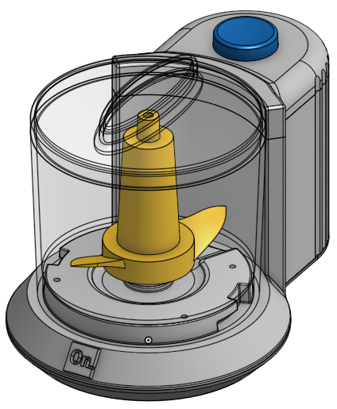

In this lesson, we will focus on creating the overall design for the chopper, before we start designing the detailed inside “guts”. Just like with the speaker, we will focus on a “top-down” design approach, and so we will start with several “layout sketches”. By the end of this lesson, we will have the overall design complete, and some of the details of the main plastic parts as shown here:

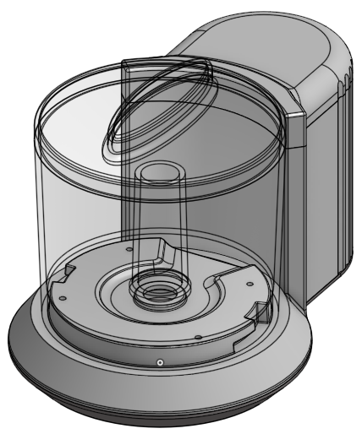

|  |
| --- |
| **Design Intent Check**: Before we get started, let’s study the layout and the parts, as this will help us develop a strategy for capturing the design intent of the assembly, as well as stay oriented as we build it up. The transparent bowl is on the left and centered around the origin, which is highlighted in blue at the bottom. In addition, we have 3 opaque plastic parts, the Top, the Main Body, and the Base. The seams between the parts are highlighted in blue as well:    Let’s also take a look at the chopper without the Base and Bowl. The Top and Main Body are highlighted below. Notice how the Main Body interacts with the parts that are not highlighted, which we will build next week. Hopefully this will give you an idea of why we added certain features to the Main Body. |

1. Let’s start by creating our layout sketch on the top plane. Here it is viewed in the “Top” orientation. Take note of the “3.5” dimension as that is very important, and notice that the left side of that dimension is our origin (highlighted in blue). Also notice that the two lines are horizontal. Name the new sketch “Layout Sketch”:

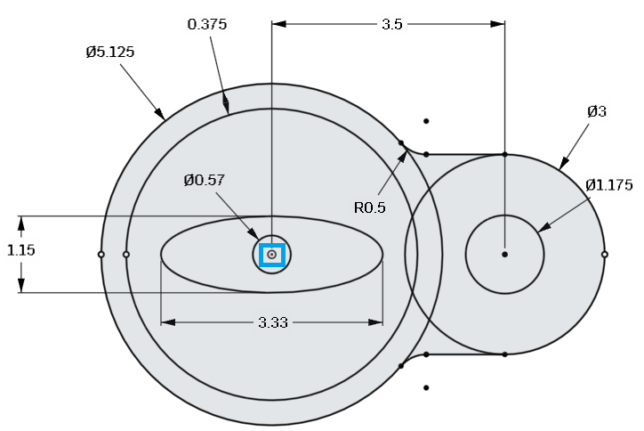

1. Next, extrude the entire profile up 4.5”. Rename the new part “Main Body”:

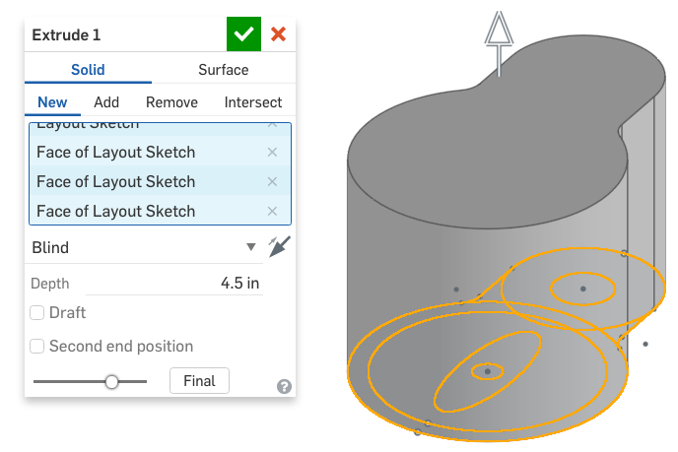

1. Now, referencing the bowl geometry, and extruding in two directions, remove material in the following manner (the model has been sectioned in half for clarity):

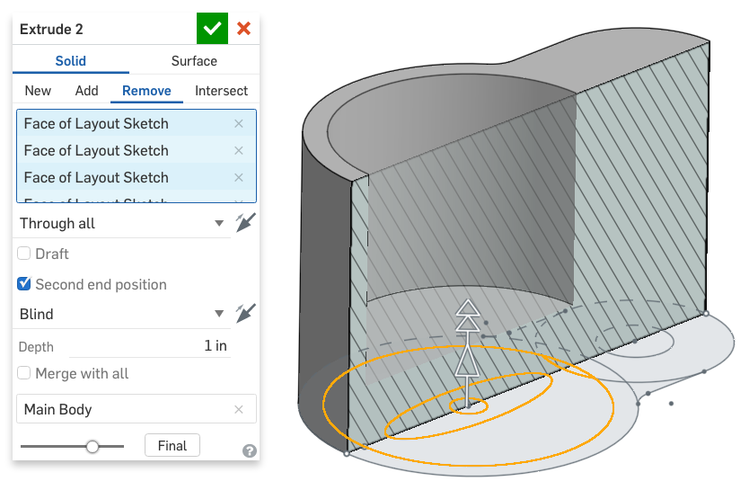

1. Next, create a new sketch (rename it called “Profile Sketch”) on the Front plane. Note the external references to the existing layout sketch, which has been unhidden. Again, the model is sectioned in half for clarity:

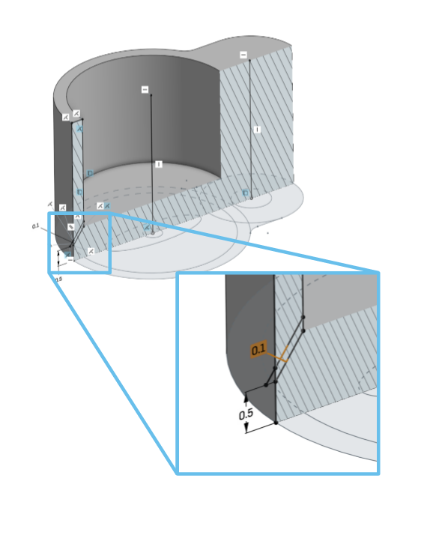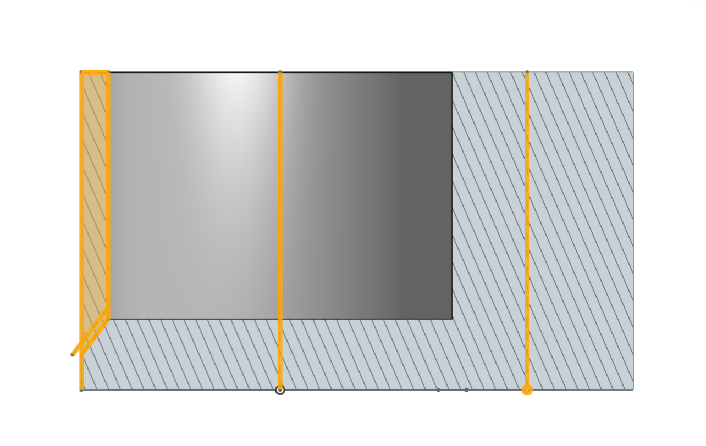

1. Revolve the Profile Sketch to remove material for the bowl:

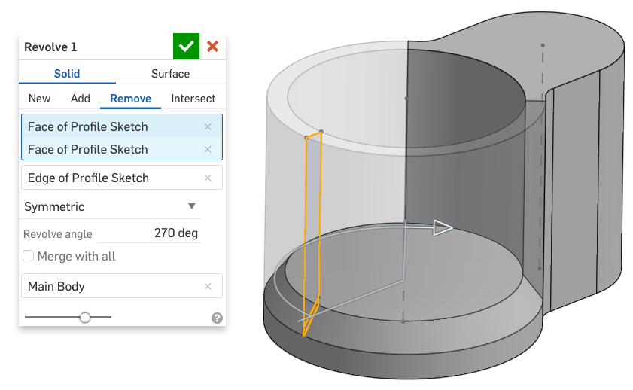

1. Next, use a chamfer feature to create the profile of the Base:

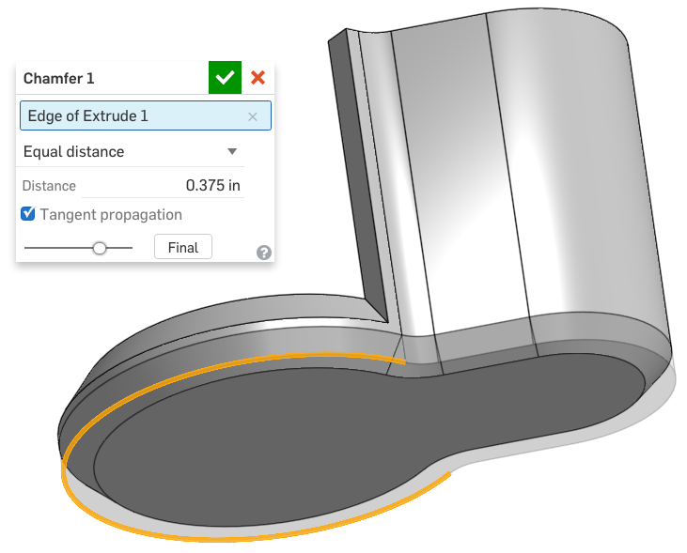

1. Next, create a sketch on the Top, by utilizing the Use/Project tool, and referencing some of the geometry from our Layout Sketch (highlighted in orange):

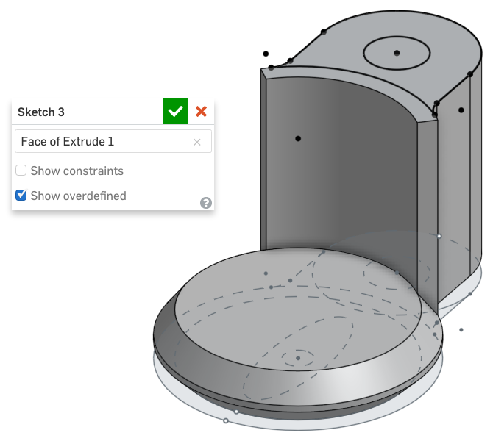

1. Next, extrude it down 0.1”:

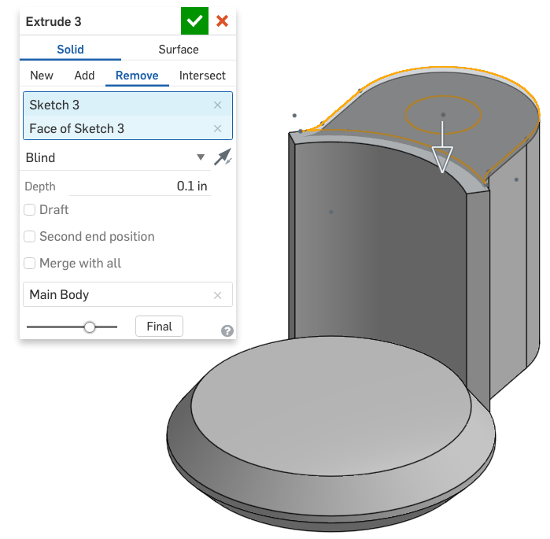

1. Next, create the following sketch on the surface that the bowl will sit:

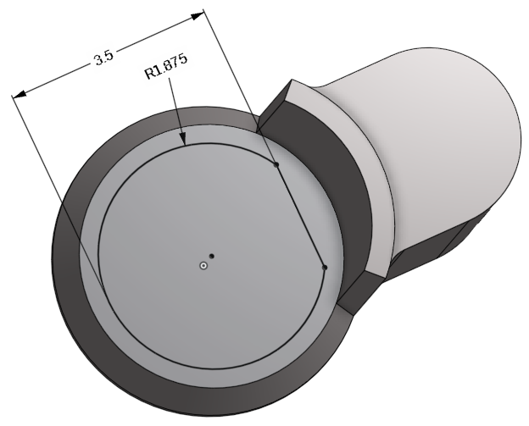

## Design for Plastic Injection Molding: Draft

Although we may have used the draft feature (and/or the draft option in an extrude) before, for the next series of features for our Chopper, we are going to add draft in strategic places of our design. Draft refers to the sloped surfaces of a 3D model (draft angles refer to the angle of the slope). So why is it important for our models to have sloped surfaces?

Draft is a necessary design feature when we are designing for certain manufacturing processes, such as Plastic Injection Molding (PIM). In the simplest form, the tooling for a mold will include two parts and four steps. Here is a graphic showing a cylinder being molded (the mold halves are identical and have been made transparent for clarity):

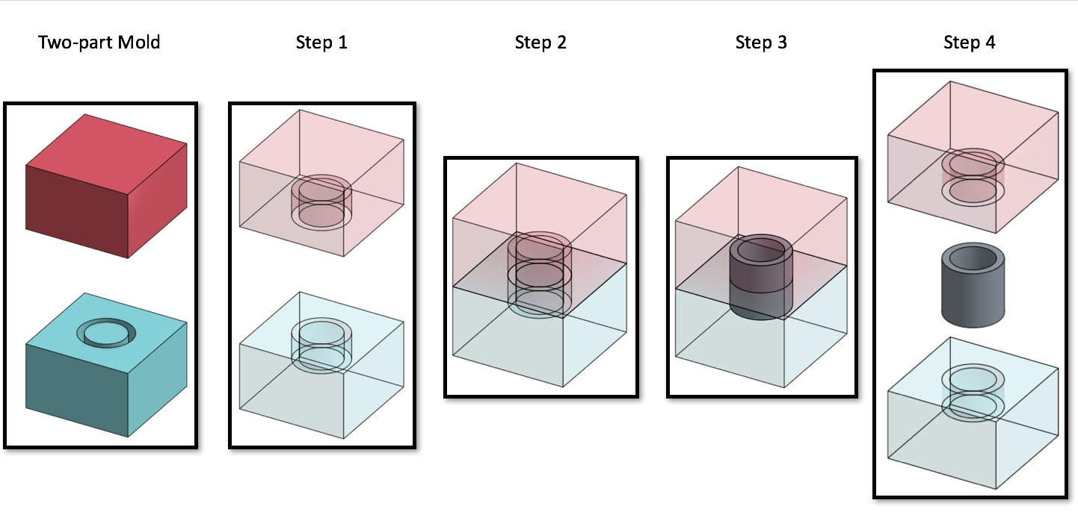

1. The mold is prepared and the plastic is melted (not shown)
2. The two halves are pressed together. The plane in which the two halves meet is called the “Neutral Plane” or “Parting Line”.
3. The molten plastic is injected to take the shape of the mold and then cooled until the plastic is hard
4. The mold is opened, and the part is removed.

In this case, the walls of the cylinder are vertical. This is not ideal, because this is parallel to the movement of the mold when it opens. When the mold is opened (step 4) the walls of the mold will slide along the cylinder. This creates heat and wear due to friction, and results in poor surface quality on the part:

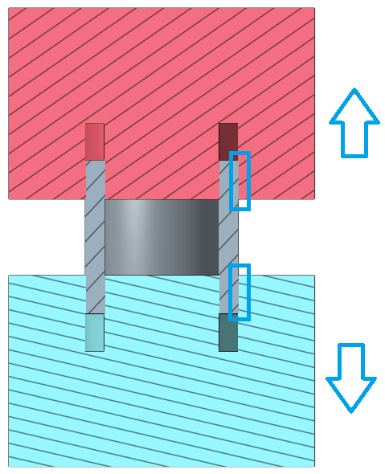

To prevent this, draft is added to the part, so the walls of the cylinder are not parallel to the mold direction. The gaps between the part and the mold are highlighted below. In this example, a Parting Line can also be seen in the middle of the Cylinder, where the Cylinder walls are the thickest:

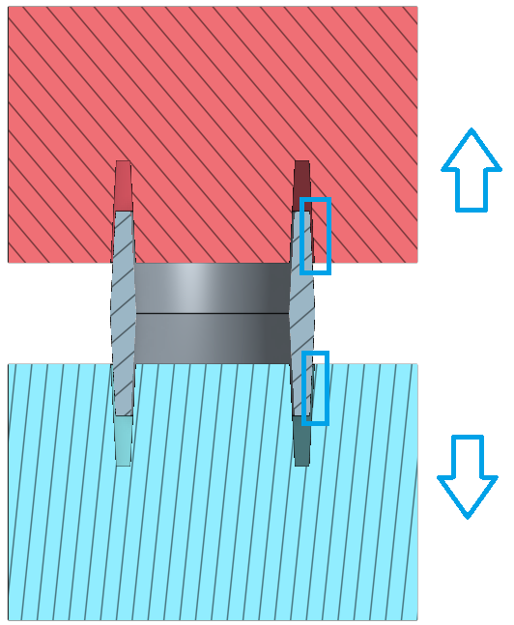

Draft can be added to a part either through the Draft Feature 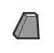, or through the Draft option in the dialog box of some of the other features. More info on the Draft feature can be found here: <https://cad.onshape.com/help/#draft.htm>.

## Radii

In addition, the walls of the cylinder end in sharp corners at each end of the cylinder. This is not ideal, because it could cause problems in machining the mold, could cause the part to “stick” in the mold, and could also cause stress concentrations in the cylinder itself when it is being used. To prevent this, small radii should be added to the corners:

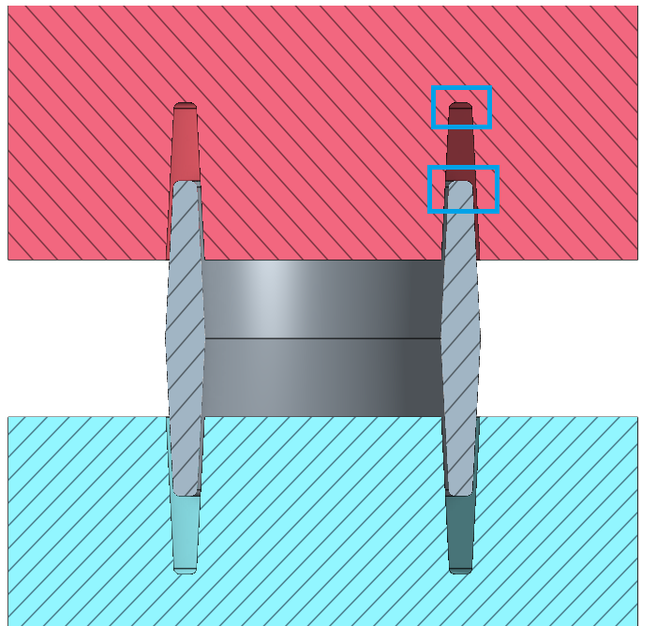

So, to recap, when a part is being designed for the Plastic Injection Molding process, the CAD geometry must include additional draft and radii that may not otherwise exist. Here is the design of the cylinder before and after it has been prepared for Plastic Injection Molding:

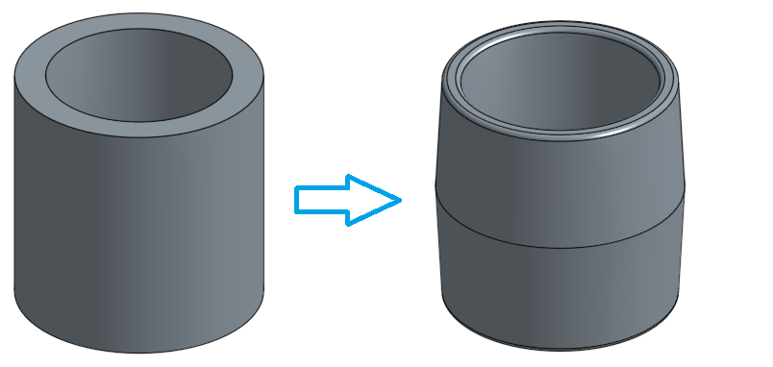

In the following section of the lesson, we will add these extra steps to get comfortable doing this in Onshape. Please note that the entire Chopper will not be drafted, nor will all necessary radii be added. If you want to manufacture these parts using Plastic Injection Molding, those features should be added afterwards as necessary.

1. Extrude the sketch upwards and, using the Draft Option, , and add 3 degrees of draft. Note the direction of the draft:

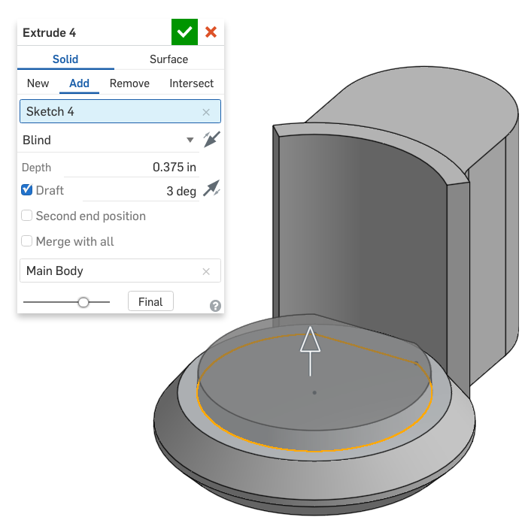

*Pro Tip: When applying a draft during an extrusion, the plane on which the sketch entity lies on becomes the neutral plane. The direction of the Draft option asks you whether you want the extruded face to be wider or narrower than the sketch on the neutral plane. In this case, we wanted our extruded part to be narrower. In some cases, you may need to zoom in for a closer look to make sure the draft is in the right direction.*

1. Next, let’s create a new sketch on top of the new surface, using symmetry as needed. Rename the sketch “Spillway Sketch”. Use sketch fillets for the arcs:

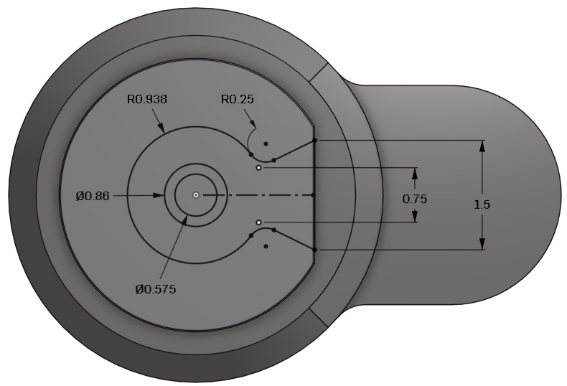

*Pro Tip: This is where using draft starts to require a little bit more time and concentration when we create new sketches. Notice how we can actually see both top and bottom edges of the draft surface. In this case, it is important that we create constraints to the bottom (outer) edge of the drafted surface. This will make sure that when we remove material, we remove it from that entire face:*

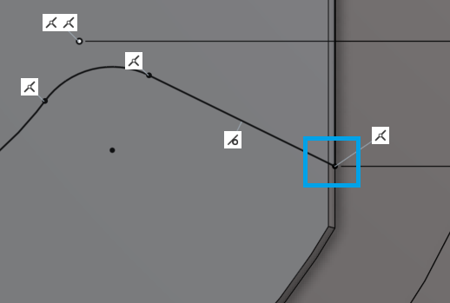

1. Next, use the Spillway Sketch to remove material:

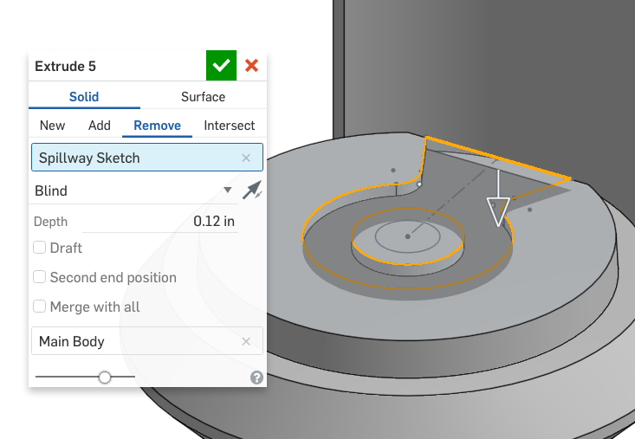

1. Next, add 45° of draft  to the sides of the new extrude, using the bottom of the extrude as the neutral plane (left picture) and the sides as “Entities to draft” (right picture):

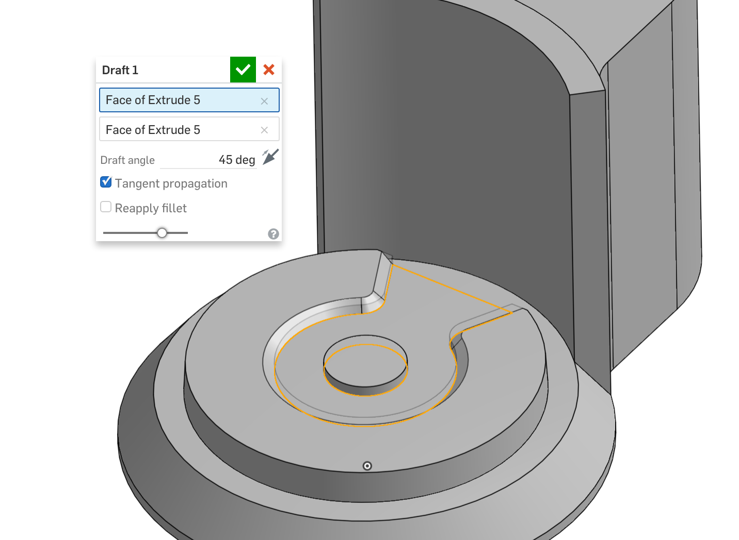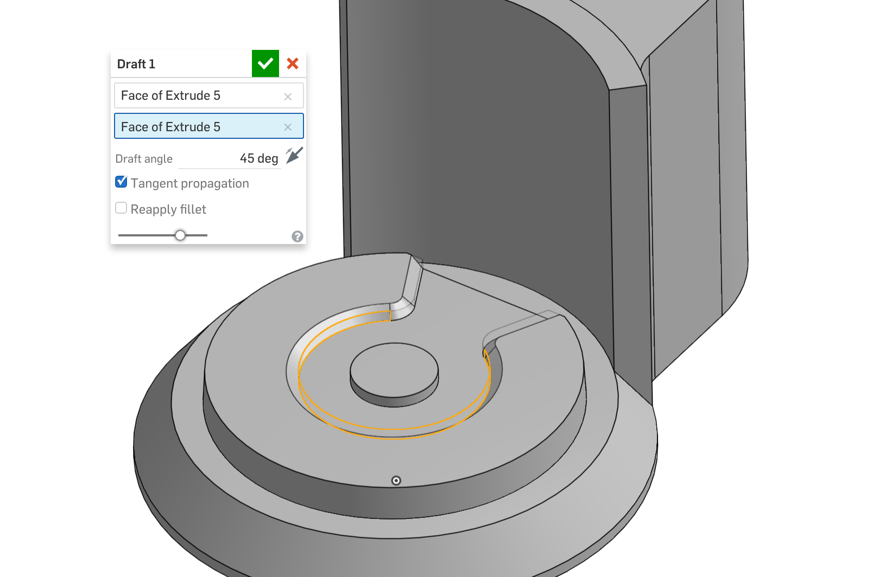

1. Next create two separate fillet features on the top and bottom of the drafted surface:

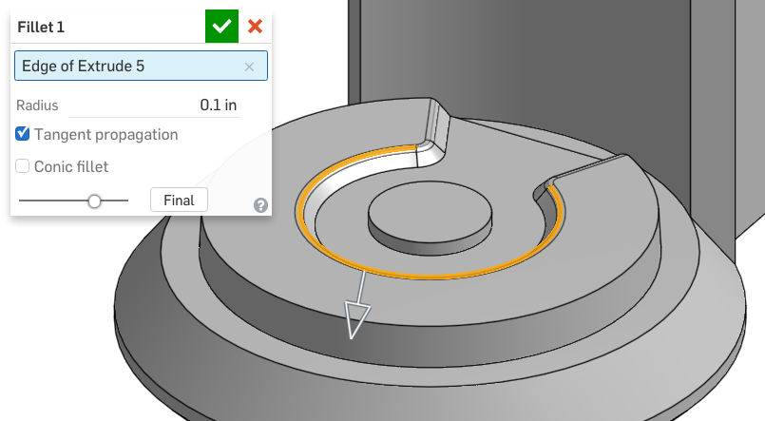

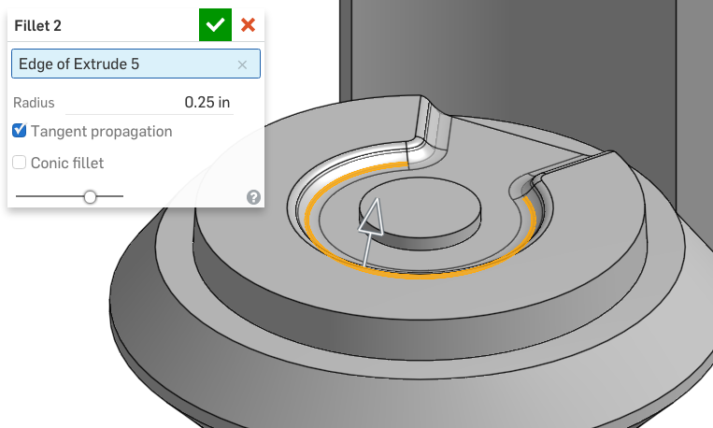

1. Next, use the Spillway Sketch to lower the height of the center boss by 25 thousandths:

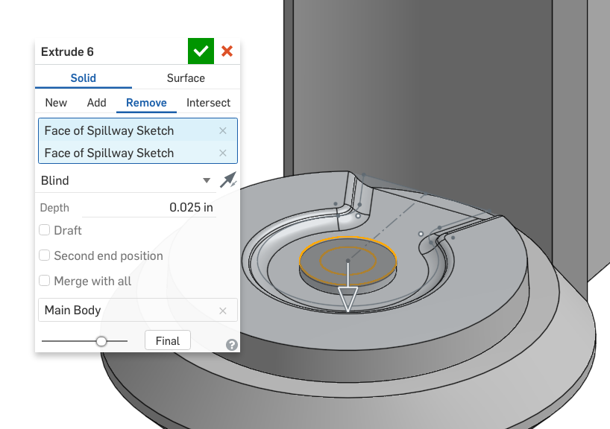

1. Next, add some draft to the center boss. Make sure it is in the right direction; the base of the boss should be larger than the top. Use the arrow  in the dialog box to switch directions.:

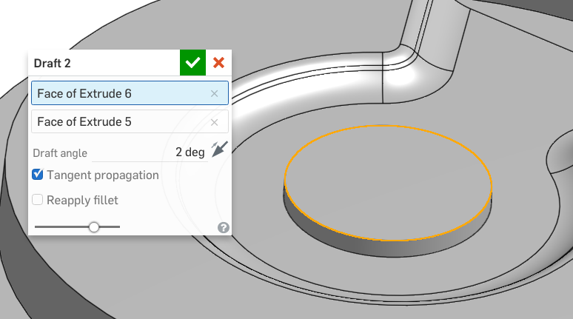

1. Next, we will create the locking “quarter-turn” geometry for the bowl. Start by creating the following sketch on the Base surface (highlighted in orange). Use symmetry, and align the edges with the origin:

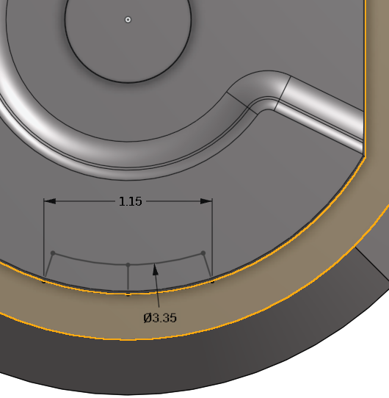

1. Use the sketch to remove material, and don’t forget to use draft:

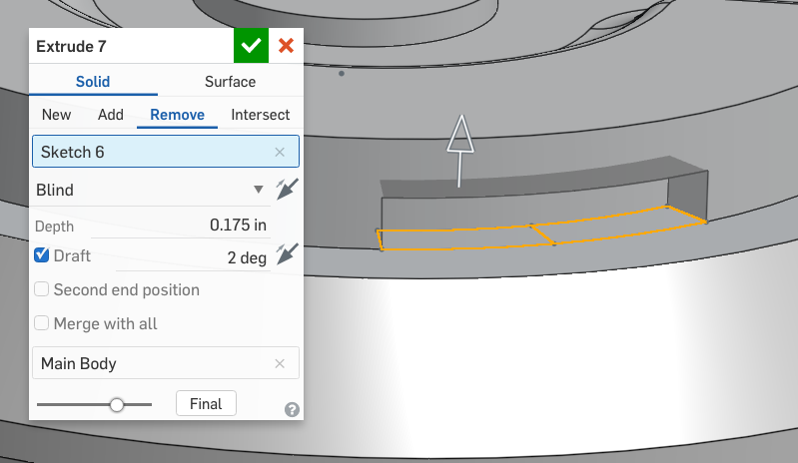

1. Using the same sketch, remove the rest of the material. Again, include draft:

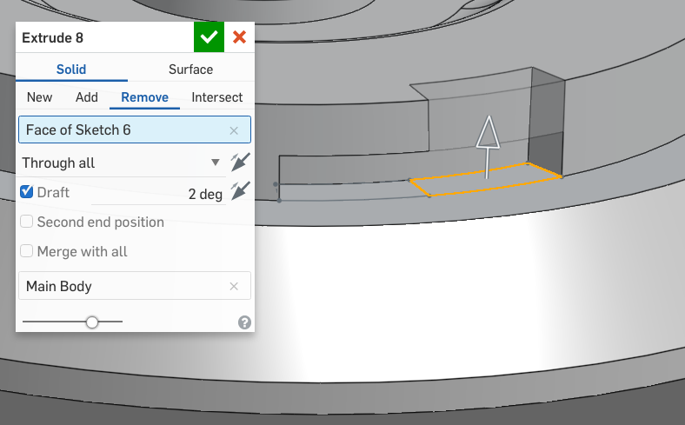

1. Next, circular pattern our new geometry, using our Profile Sketch as a reference:

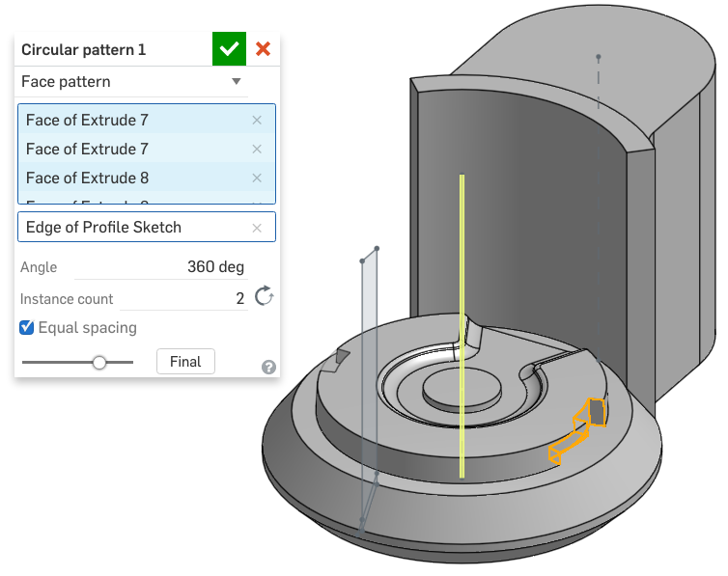

1. Next, let’s add a 0.020” (also referred to as “20 thou” for “20 thousandths”) fillet to all of the edges of our spillway:

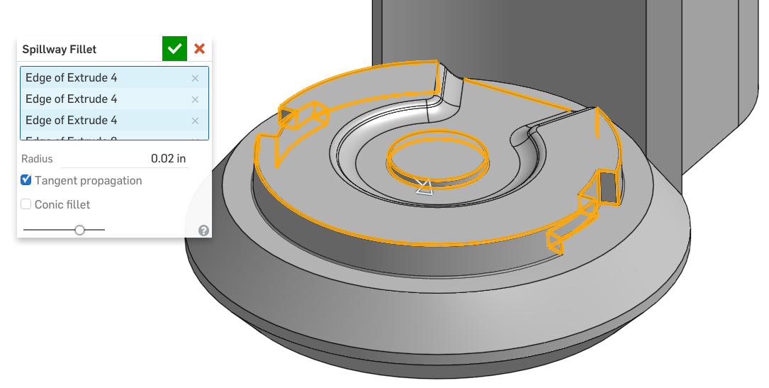

1. Next, add a large profile round (fillet) to the top of our Chopper:

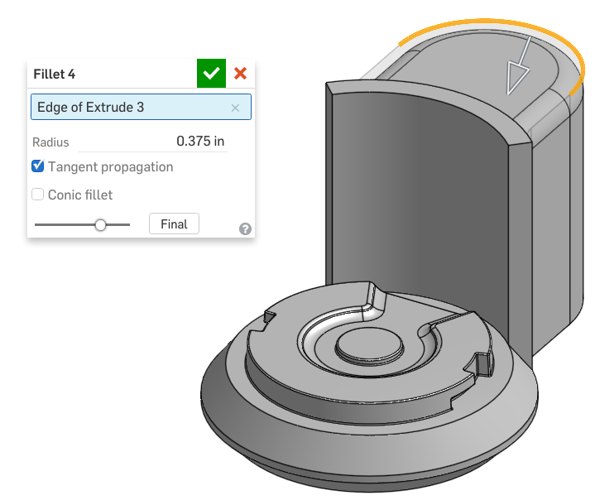

1. Next, add another larger fillet to the top of our Chopper:

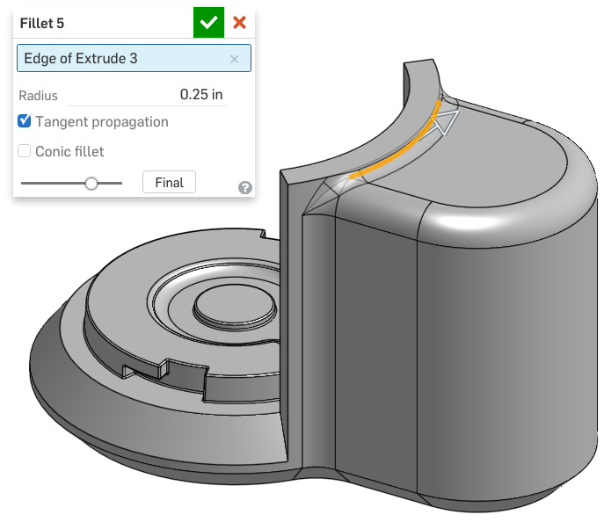

1. Next, we’ll add a series of fillets to the Main Body section of our Chopper. Start with these edges:

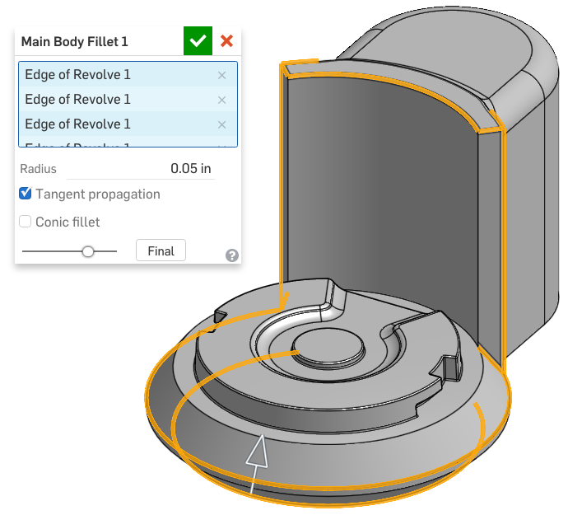

1. Next, add fillets to these edges:

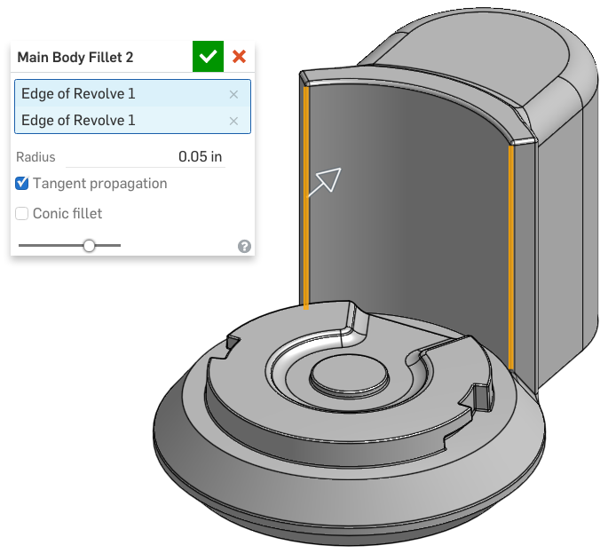

*Pro Tip: Fillets can be tricky. You may be wondering why we added the the last two vertical fillets in a separate feature (Main Body Fillet 2). This is because we would have gotten an error if we had add it in the previous feature. This is because of the way the bottom edge is designed:*

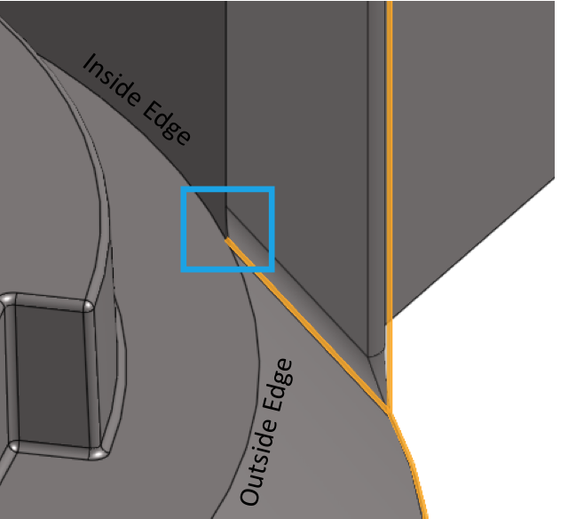

*The rectangle shows a challenging intersection of edges. To the left of the intersection, the large round edge is on the inside of two faces, and to the right of the intersection, it is on the outside of two faces. As a result, CAD programs have difficulty creating fillets on this edge, and on other edges that intersect this edge at the transition. For this lesson, we have filleted the vertical edge separately, and will leave the rest of the design alone.*

1. Next, let’s create a sketch on the Front plane, called Split Sketch:

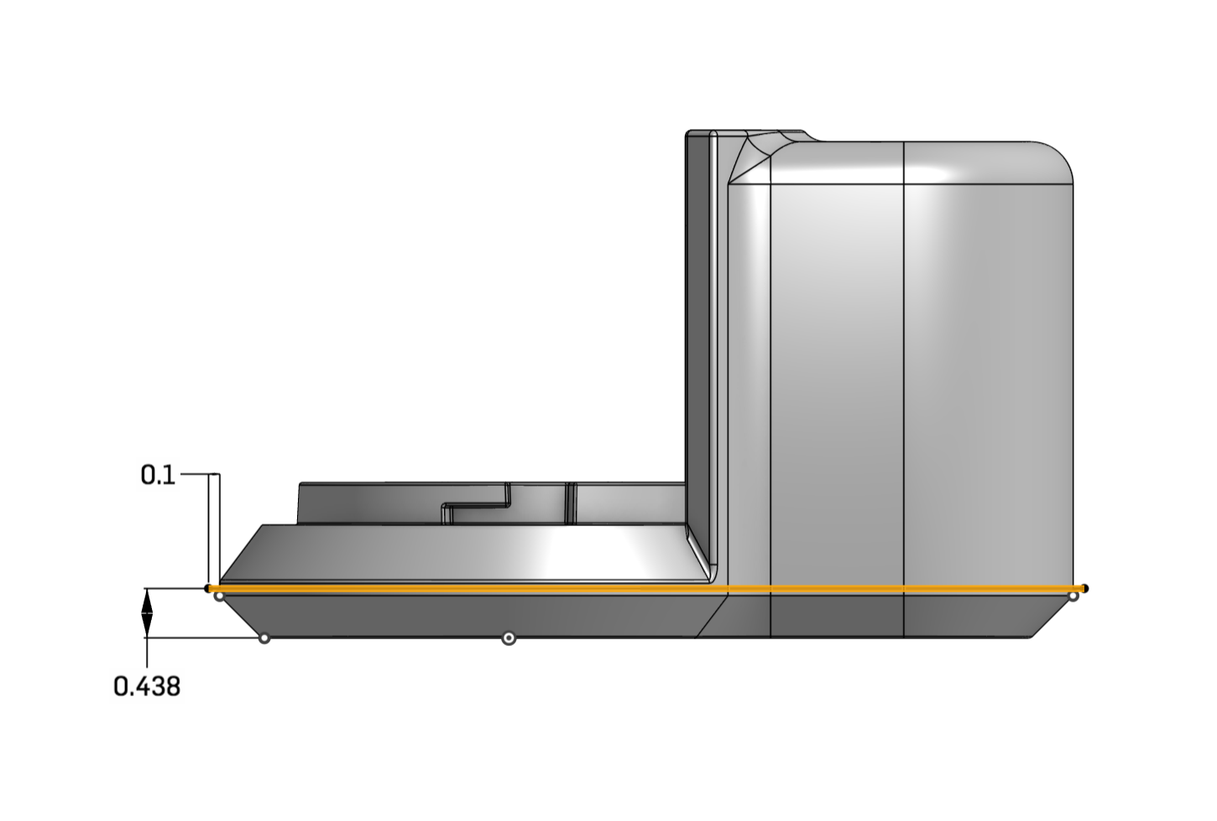

## Surfaces

Onshape can create both solids and surface. When we extrude a sketch region the result is a solid, but when we extrude just a line (or an open contour of sketch entities) the result is a surface. To create a surface in Onshape, just select the Surface toggle in the dialog box:

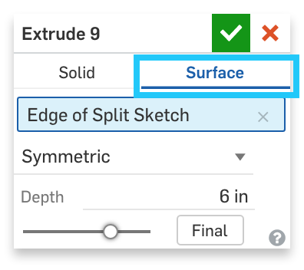

We have chosen to create a surface for a specific reason (we will soon see), but for most other reasons, a surface part can be treated just like all other parts in Onshape.

1. Using the bottom line from the Split Sketch, extrude out a surface like this:

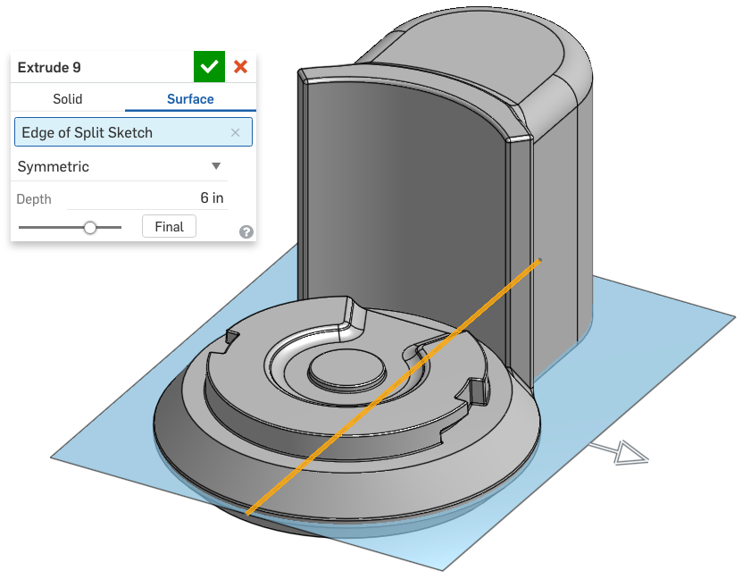

## Split

We specifically created the previous surface, so we can use it to split our Chopper Part. The Split Feature  allows a part or a face to be physically split by an intersecting surface. In our case, we will use this new surface to create the seam between the Main Body and the Base. Using the split feature is integral to Top-Down design, because it allows us to design the entire Chopper as a single part, and then split it up into separate pieces for manufacturing and assembly reasons. More info on the Split Feature can be found here: <https://cad.onshape.com/help/#splitpart.htm>

1. Using our new surface as the tool, split the original part into two new parts. Name the top part the “Main Body”, and name the bottom part the “Base”:

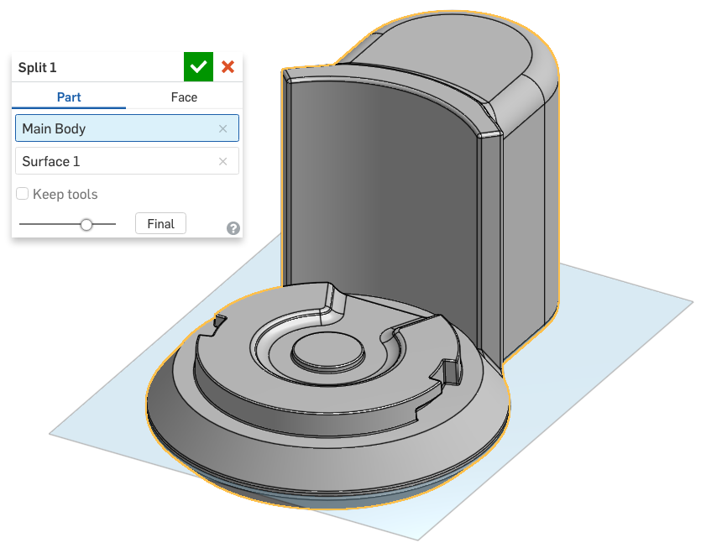

*Pro Tip: You were probably wondering why we extended these lines 0.1” away from the part. This is done to make sure that the line is absolutely, and always, longer than our parts. If we do not explicitly make the, longer than our part, we could get issues in the Split feature. Now, if we make the part bigger, the split lines will grow longer as well!*

1. Next, we’ll create the “ribbed” texture on the outside of the Main Body. Start by creating the following sketch on the Top Plane. Use the Layout Sketch (shown below) for reference:

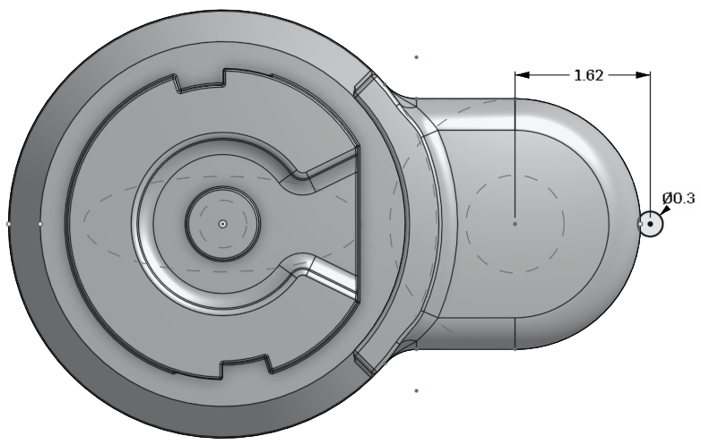

1. Use the sketch to create a new part, by extruding it up to the top surface of our Main Body part (highlighted in orange):

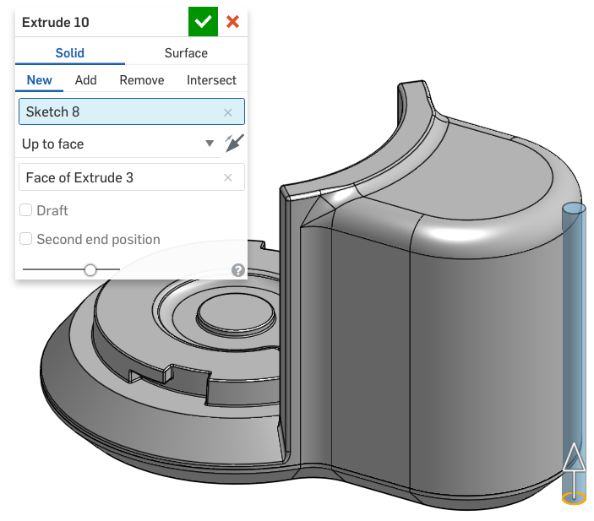

1. Next, create a 10 X 10° circular pattern of this new part using our Profile Sketch as a reference:

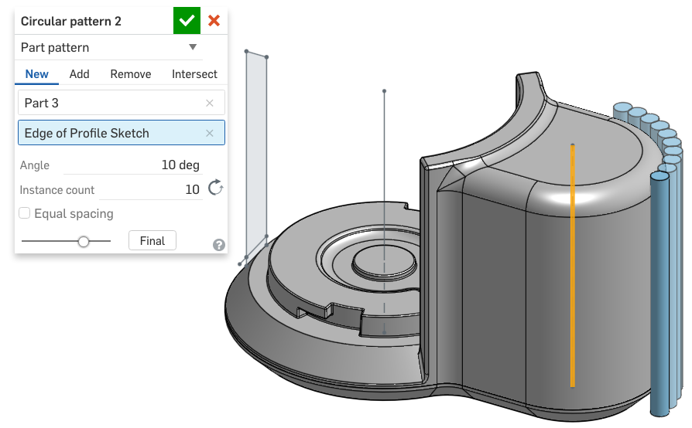

*Pro Tip: Note how we are continuing to reuse the Layout and Profile sketches again and again. Particularly with all of our revolve features, we are always referencing the vertical lines we conveniently sketched in our profile Sketch. Consistency and attention to detail like this, are what create smart, robust CAD models that regenerate quicker and with less errors!*

1. Next, mirror the newly patterned parts across the Front Plane (there should only be 9 parts):

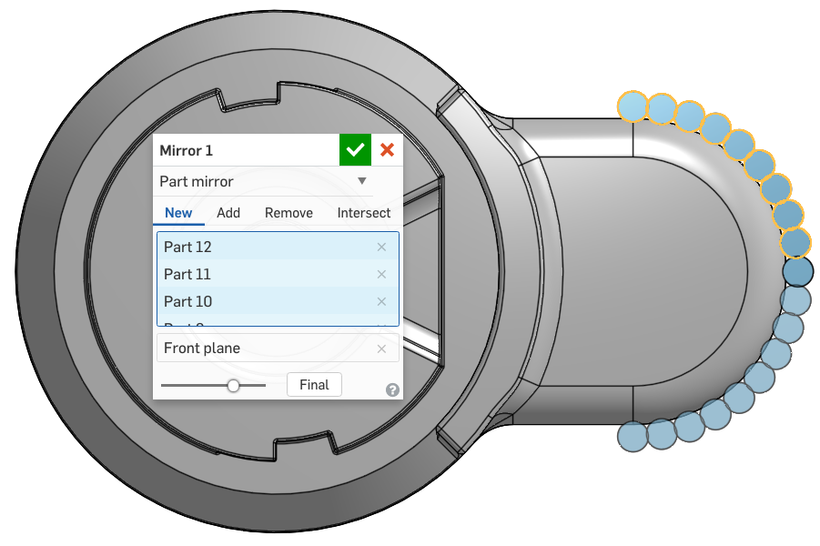

1. Next, use a Boolean subtract to create the ribbed texture. Note that the feature scope is just the Main Body part, and not the Base:

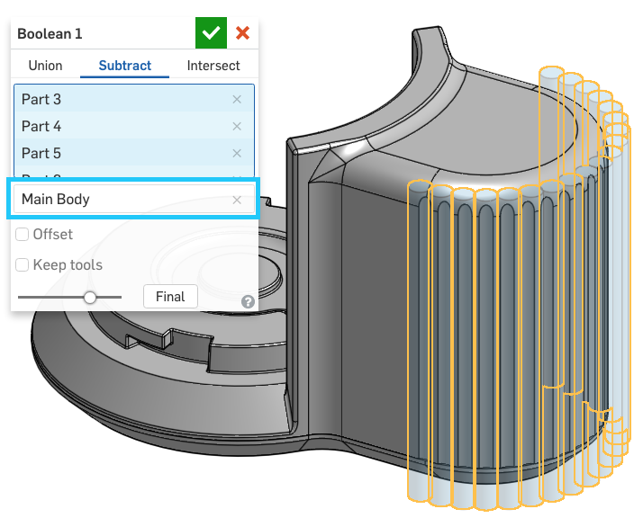

1. Next, we want to split the Main Body to create the Top part. Let’s try a different method this time. Create a plane 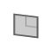 that is 0.55 in offset from the highlighted plane below:

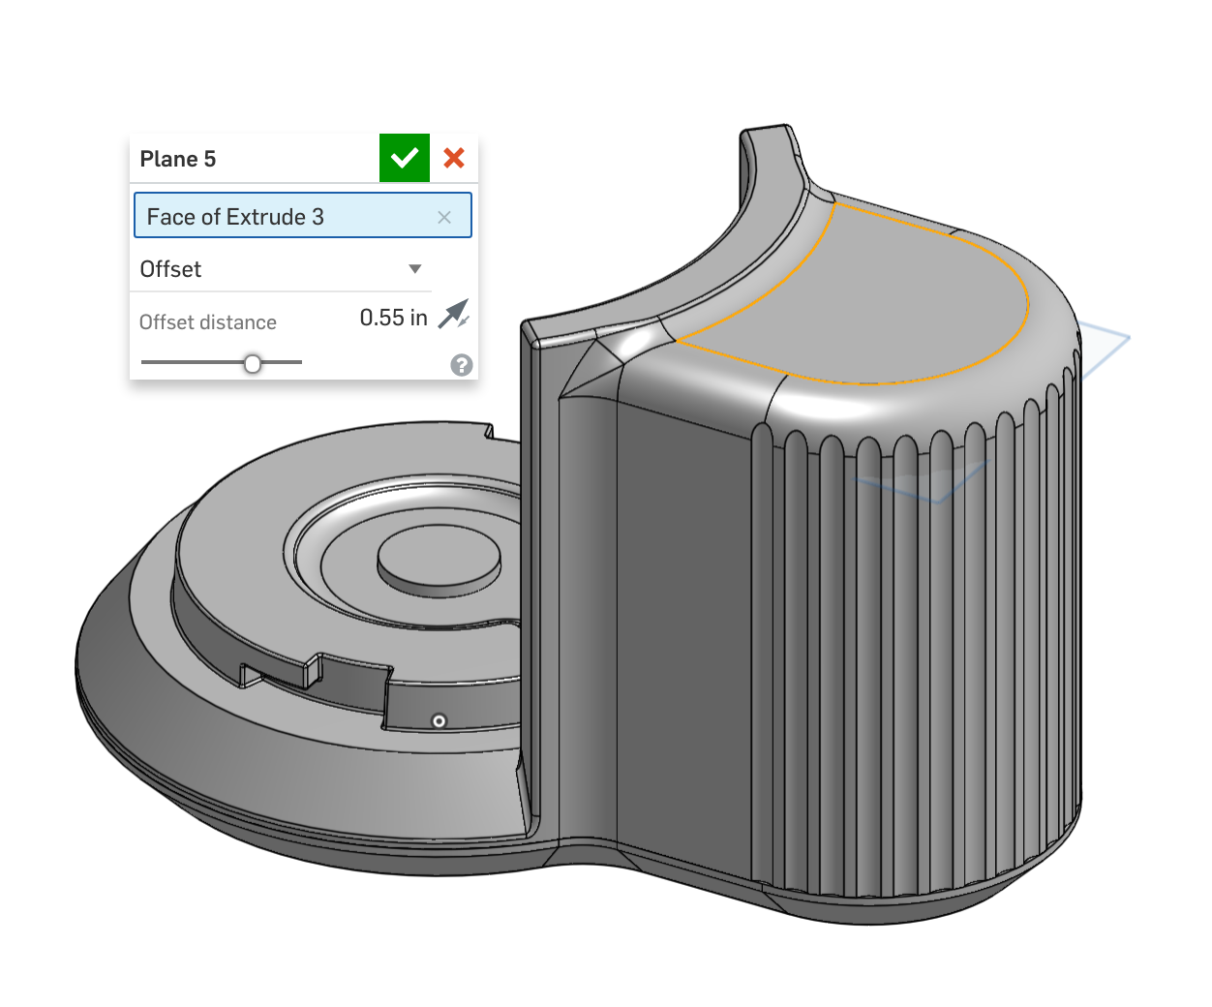

1. Now we’re going to be using the plane to split the Main Body. Remember that planes extend infinitely, so we don’t need to dimension it in any way like we did with the surface! Rename the parts “Top” and “Main Body”:

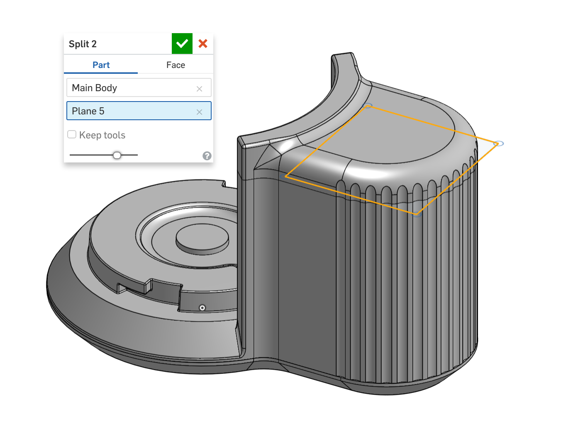

## Variables/Expressions

Variables are yet another tool to be used in “Top Down” design. In Onshape, Variables are exactly the same as what we learned in our high school algebra classes; they are especially useful in product design and engineering because features within a model are often algebraically related. A Variable can be created and referenced by subsequent dimensions and features, such that updating those dimensions and features is easily done by updating the variable itself. In addition, variables can be used in equations, expressions, and a whole array of mathematical functions. It is a powerful way to drive the design, and by giving the variables meaningful names, it is also a way to document design intent (for example, you can give the name “offset” to a numerical value that represents the offset; it has much more meaning than leaving it as a number). More information about variables can be found in the Onshape help here: <https://cad.onshape.com/help/#variable.htm> and more information about different ways to enter data into numeric fields (such as expressions) can be found here: <https://cad.onshape.com/help/#numeric-fields.htm>.

1. Create a new variable 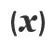, called “thk” (which stands for “Thickness”), and set it equal to .075”

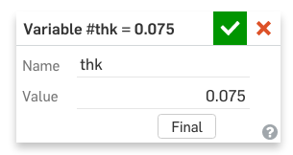

1. Next, shell the Base .075”. However, instead of typing in .075, type in “#thk” (without quotations) and press [enter]:

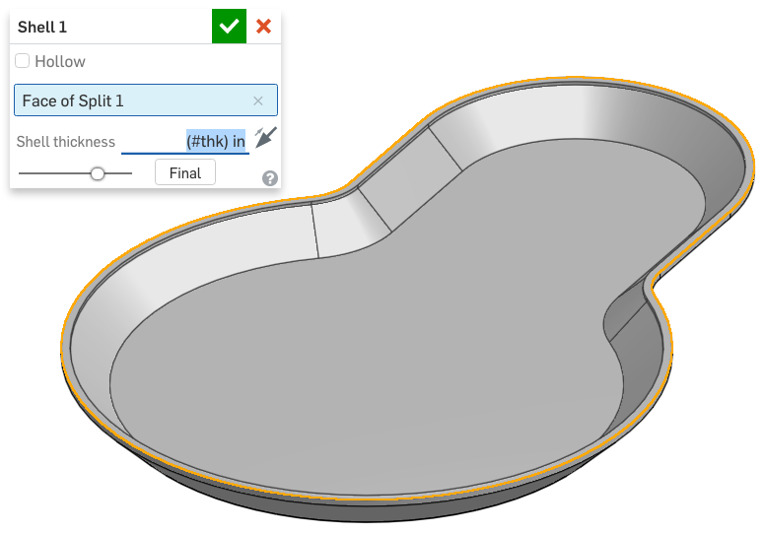

*Pro Tip: Notice that we only typed in “0.075” for the value of the variable. If you just write “0.075” within the variable, then the unit is defined in the dimension of the feature that uses the variable (such as in the shell thickness in the example above). However, if you define “#thk” to be “0.075 in” instead, you’ll get an error if you type “(#thk) in” in the feature. In most cases, it’s better to just write “0.075” and depend on the feature for the dimensional units, however, it’s worth being aware that you can do either.*

1. Next, shell the Body using the same method:

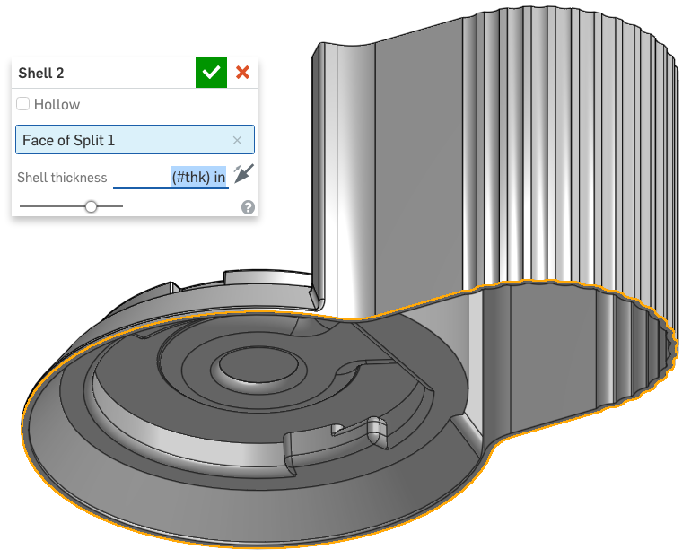

1. Next, let’s also shell the Top the same way:

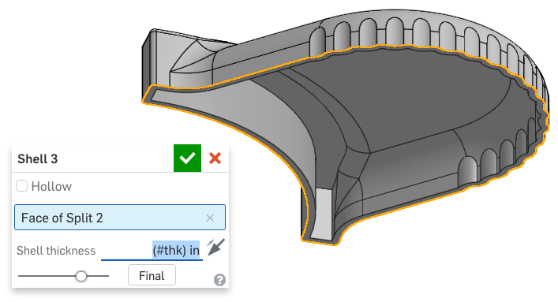

*Pro Tip: Try changing the value of “thk”. The thickness of your model should change instantly. Here is a look at what happens when the thickness of the design is doubled:*

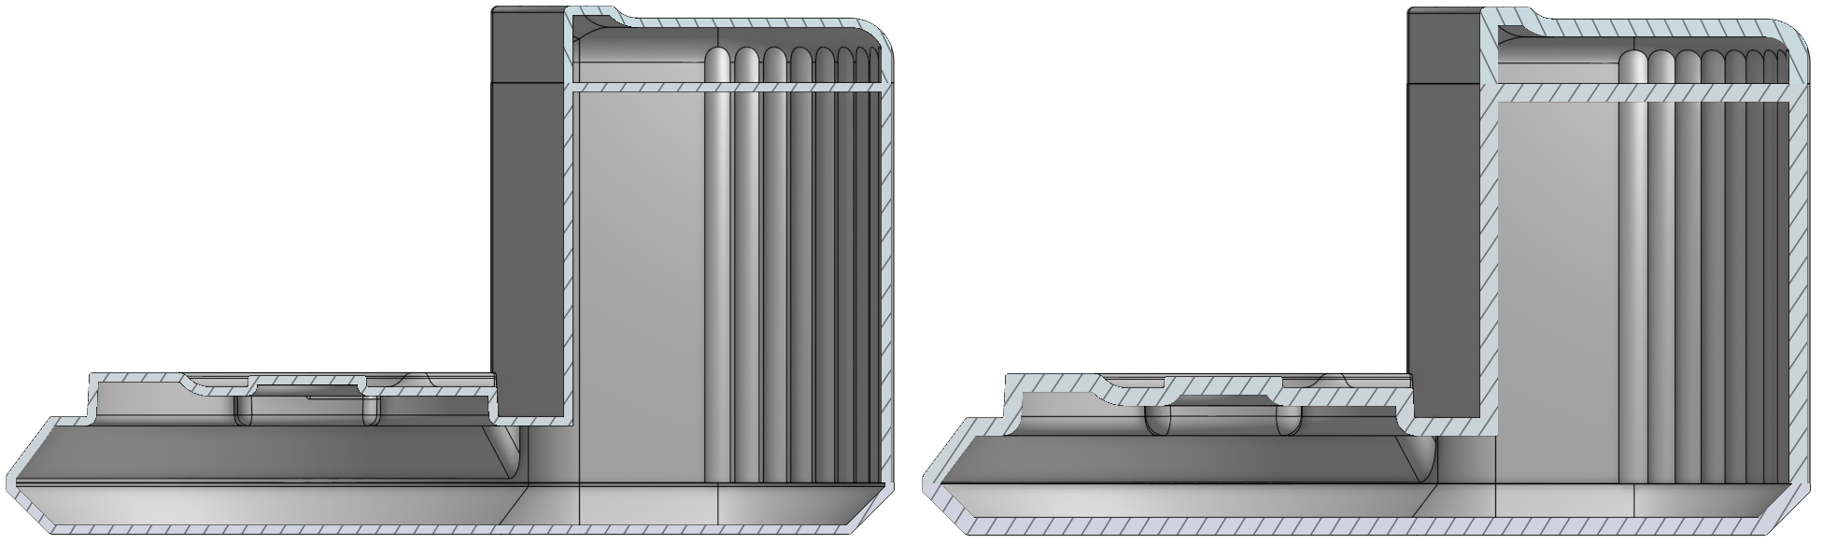

*That’s why variables are so powerful, because with one number change we can update several features across several parts. Since the thickness represents an actual manufacturing parameter (the nominal thickness of our plastic parts) the variable helps us to express our design intent. It’s not uncommon for a nominal wall thickness to change while optimizing the molding process, so using variables like this makes updating the entire model quick and easy.*

1. Next, make a hole in the Main Body beneath the bowl (for the rotating shaft to pass through) using the Spillway Sketch as a reference:

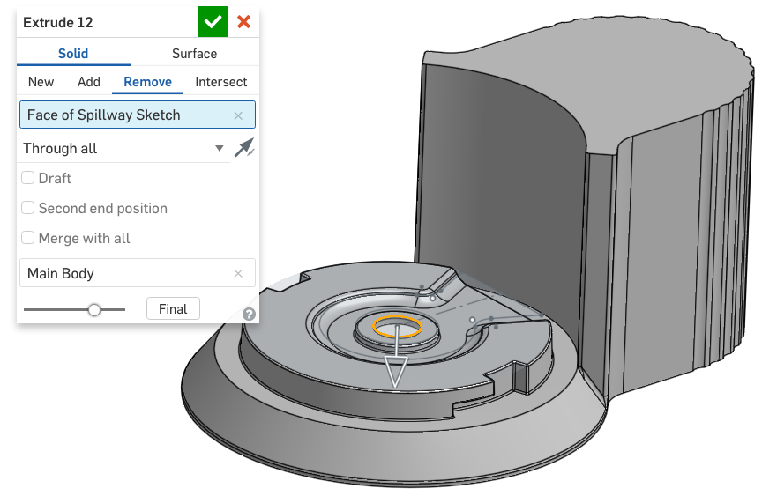

1. Next, we’re going to add some features to the inside of the Main Body. Start by creating a sketch on the inside of the bottom of the Base (highlighted in orange below). The sketch will be used to place screw bosses, so just as before, it just needs to be points. In the sketch below, construction lines have been used for symmetry constraints (the 2” dimension is centered about the origin):

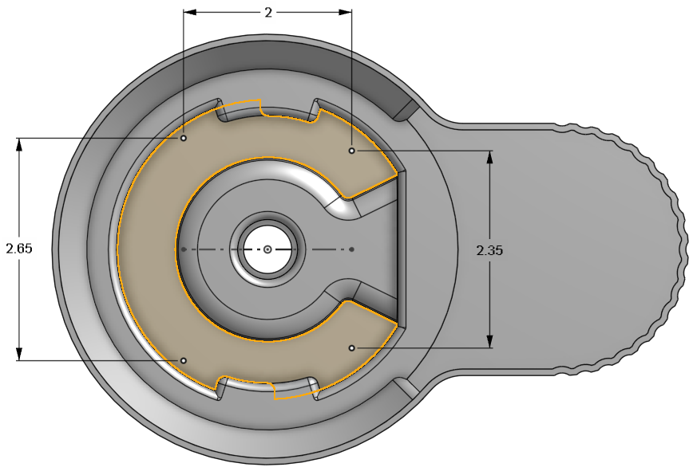

1. Next, let’s add two screw bosses 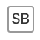, referencing the left side of our sketch. Remember that we used the screw boss FeatureScript feature in [Week 7](https://docs.google.com/document/d/1znqEavmboxS2RZbNdsSpX13e-ksb020wi40RJC1xs4s/edit#heading=h.bcb69dfea4ad):

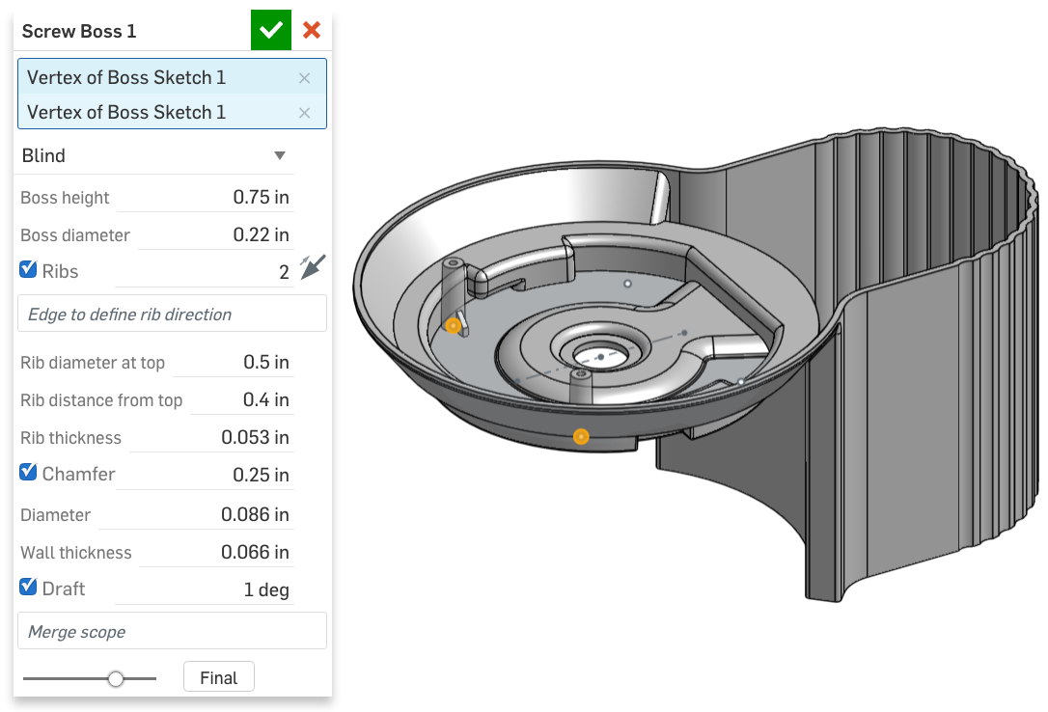

1. Next, let’s add two more bosses, referencing the right side of our sketch:

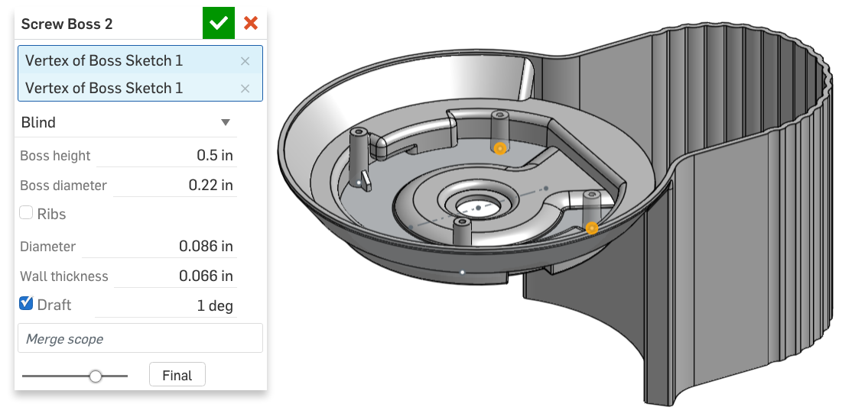

1. Next, create another sketch to reference for a couple more screw bosses on the inside of the Main Body up towards the Top (the sketch surface is highlighted in orange). Rename the sketch “Boss Sketch 1”:

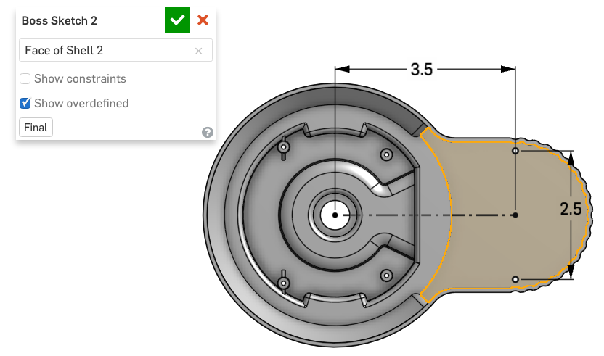

1. Next, use the sketch to create two new screw bosses:

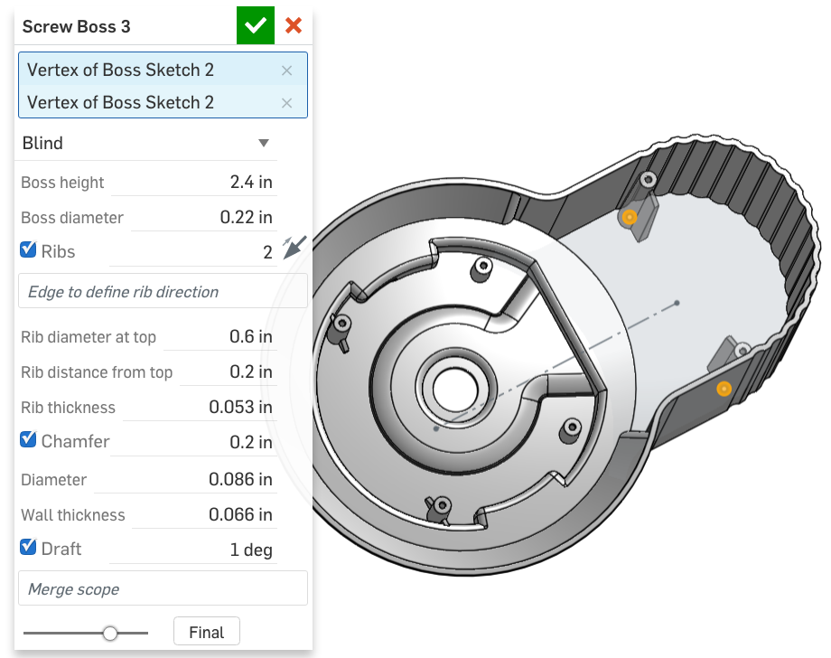

1. Next, create a plane offset from the inside surface of the Main Body, in the direction shown below. Rename the plane “Rib Plane”:

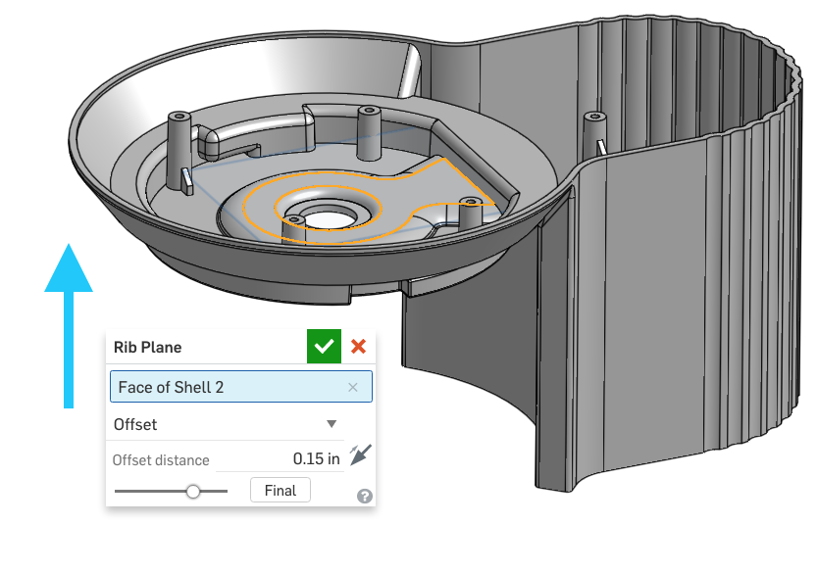

1. On this new plane, create the following sketch, which we will use to create a rib feature. There are QTY = 8 symmetric radial ribs, encompassed by two construction circles. The .02” dimension shows the outer construction circle is offset from an existing circle in our Layout Sketch (highlighted in orange):

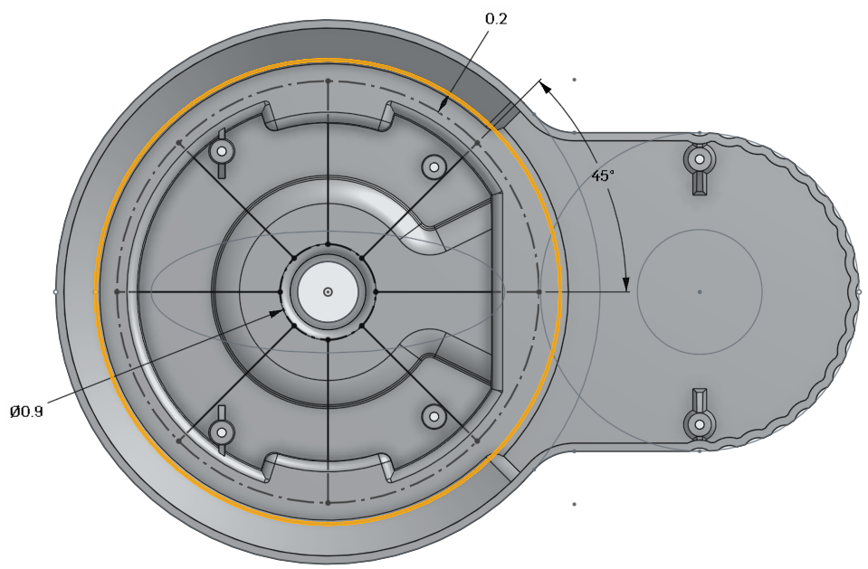

1. Next, create the 8 ribs using the Rib custom feature 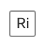 we learned in [Week 7](https://docs.google.com/document/d/1znqEavmboxS2RZbNdsSpX13e-ksb020wi40RJC1xs4s/edit#heading=h.8xxn79wmj2x8). Instead of typing in the thickness, type in the equation “.7*#thk” (without quotations):

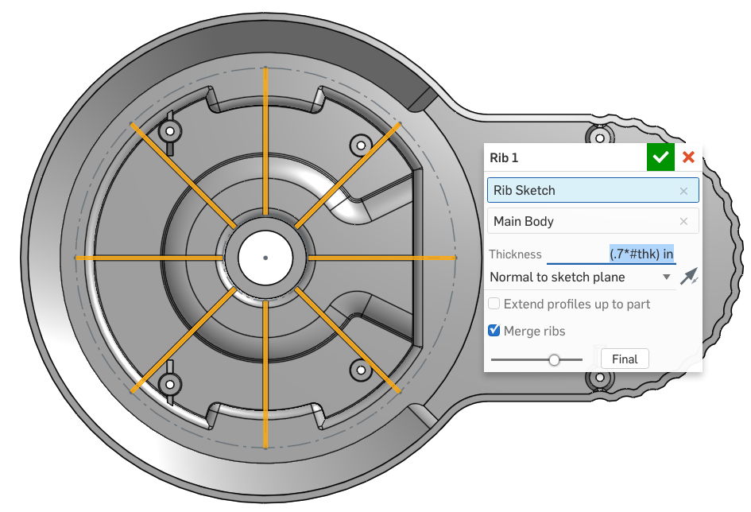

This is how the rib should look like afterwards:

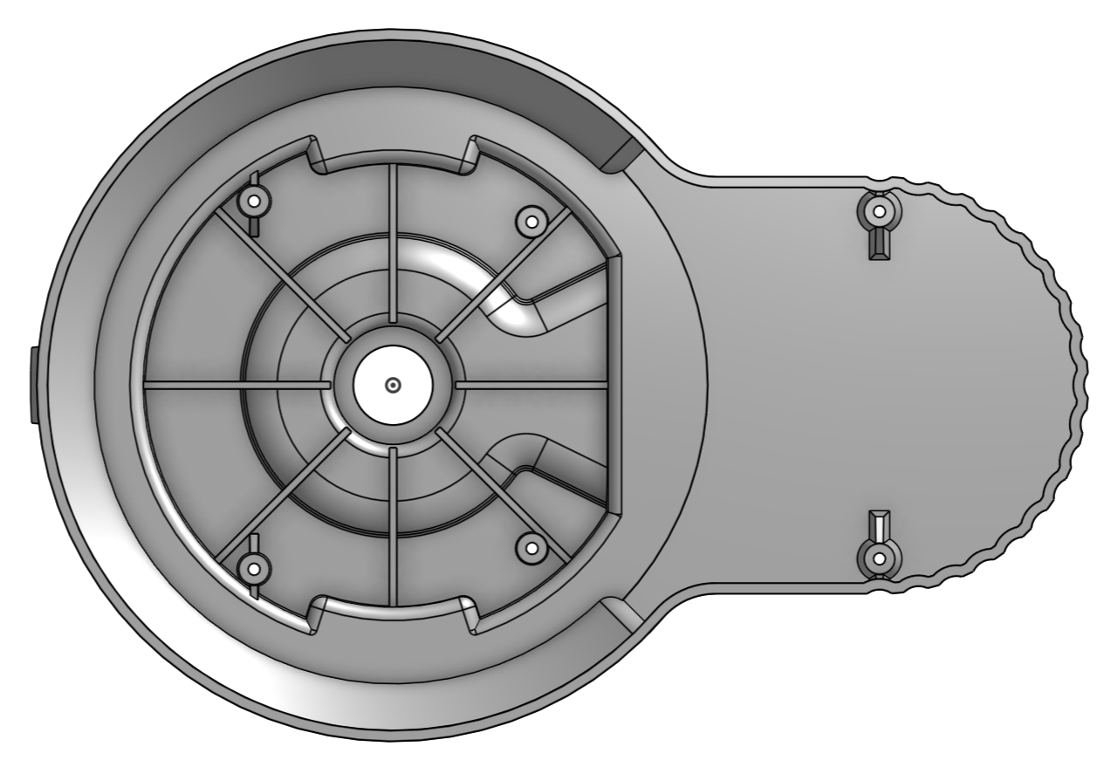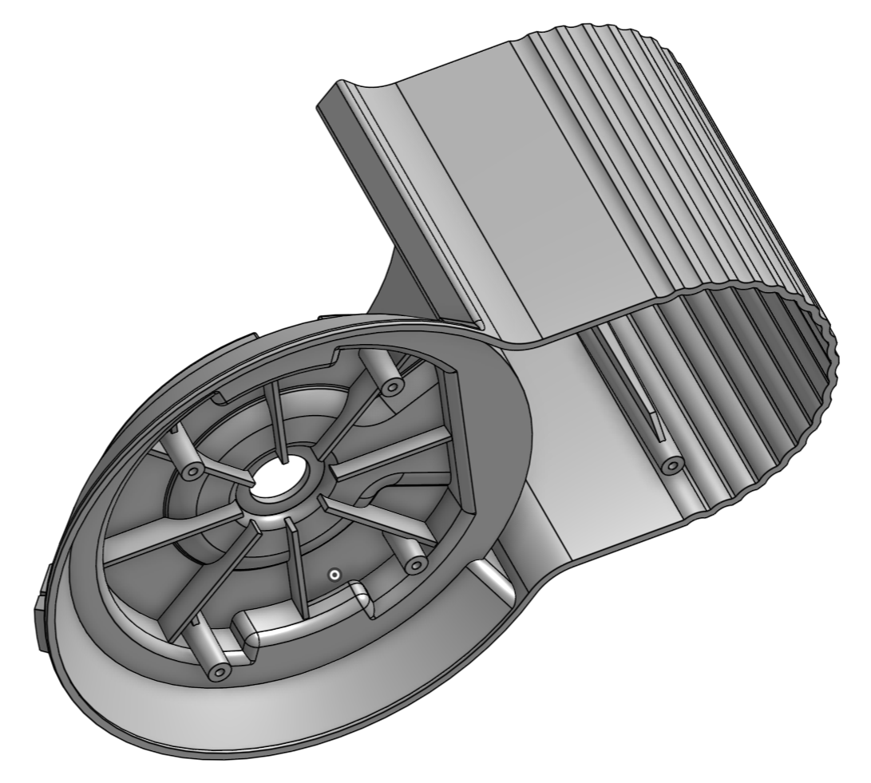

*Pro Tip: For the thickness of our ribs, “(.7*#thk) in” means “multiply the thickness variable by 0.7 and assign that value to the thickness of this rib feature”. In plastic injection molding, it is common to have rib thicknesses be approximately 70% of the nominal part thickness. Onshape automatically calculates mathematical expressions for you so you don’t have to!*

|  |
| --- |
| **Design Intent Check**: Now, we’ll be making the bowl and cover. They should both be hollow. Notice the rotational symmetry of the bowl and the curved top of the cover. |

1. Now, we will change our focus to designing the bowl. Start by creating a new sketch on the Front Plane, and rename it “Bowl Profile”. Note the following design intent in the sketch: The use of symmetry and diameter dimensions, the reference to the origin, the .05” gap between the bowl and the spillway, and the use of the offset tool to create the 0.4” offset curve at the top:

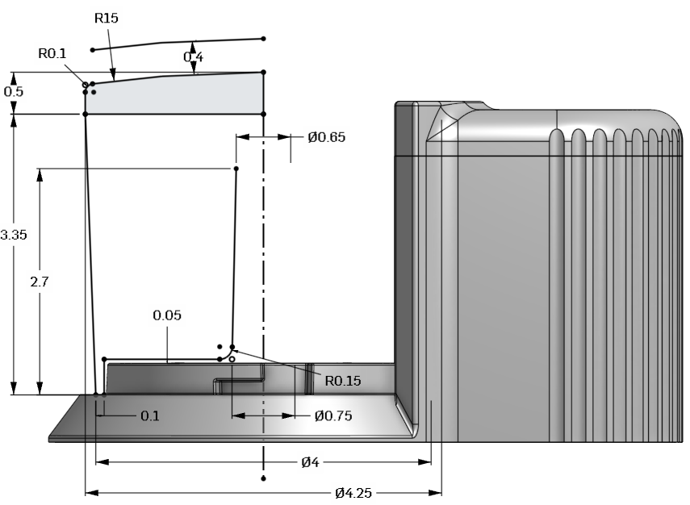

*Pro Tip: Here’s a hint for the highlighted arc in the picture below - the center of the arc is vertical to the origin, and the arc is tangent to the R0.1 sketch fillet.*

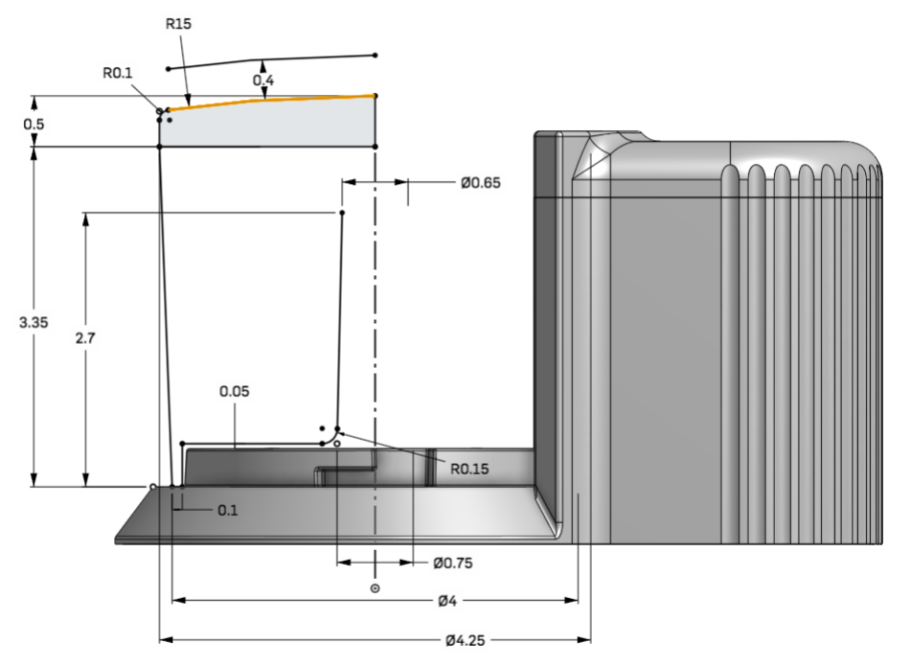

1. Use a portion of the Bowl profile sketch (shown in orange) to revolve a surface around the center construction line:

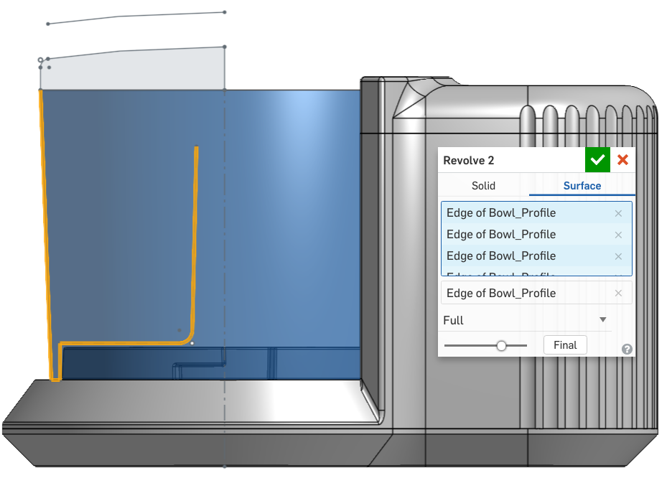

1. Thicken 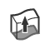 the new surface to create the bowl by clicking on the surface from the parts sidebar. Material should be added inside the bowl, away from the Main Part, so change the direction  if needed. Rename the new part “Bowl”:

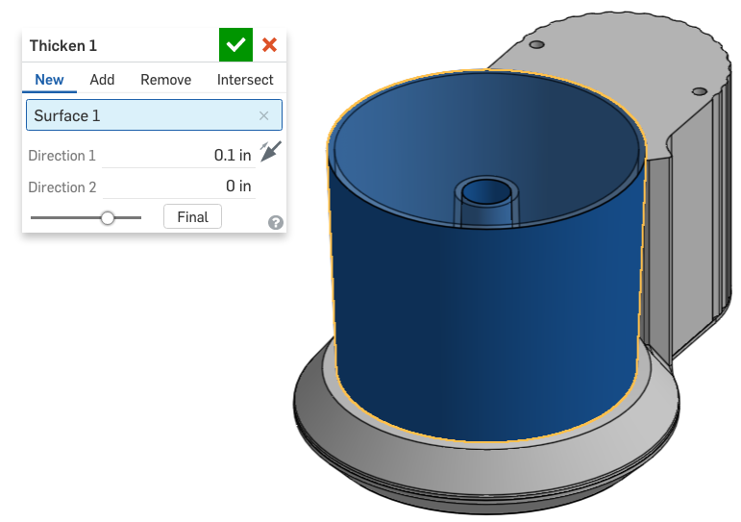

1. Next, revolve the top portion of the Bowl Profile sketch to create a new part for the cover of our bowl. Name the new part, “Cover”:

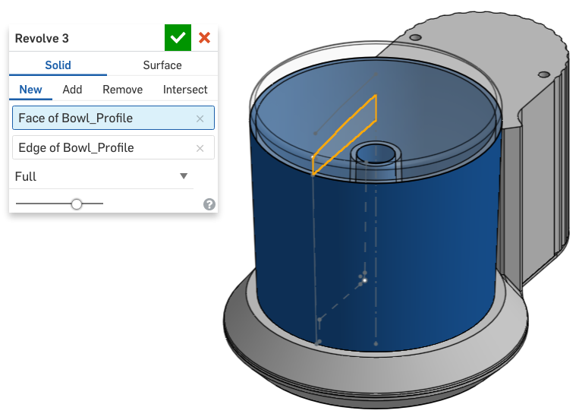

1. Next, revolve the top edge of the Bowl Profile sketch to create another surface:

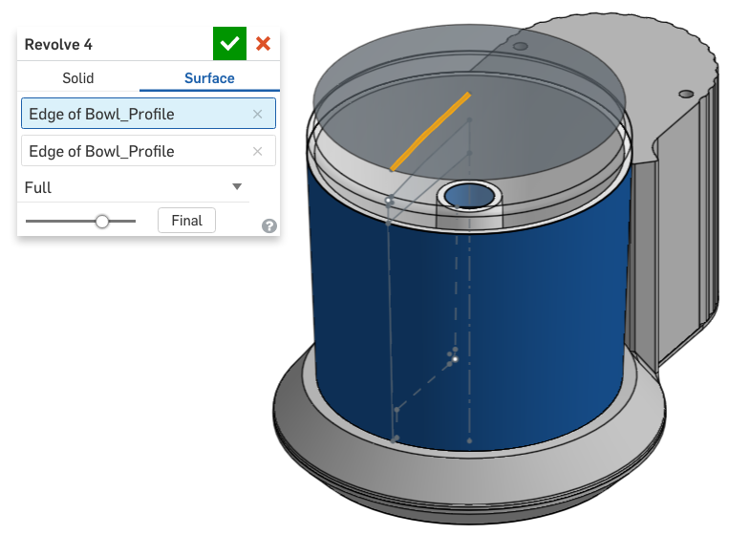

1. Next, use the Layout Sketch to create the handle of our Cover. Note the use of two “up to face” directions; the first one is to the top surface (floating above our bowl), and the second one is to the top surface of the cover itself:

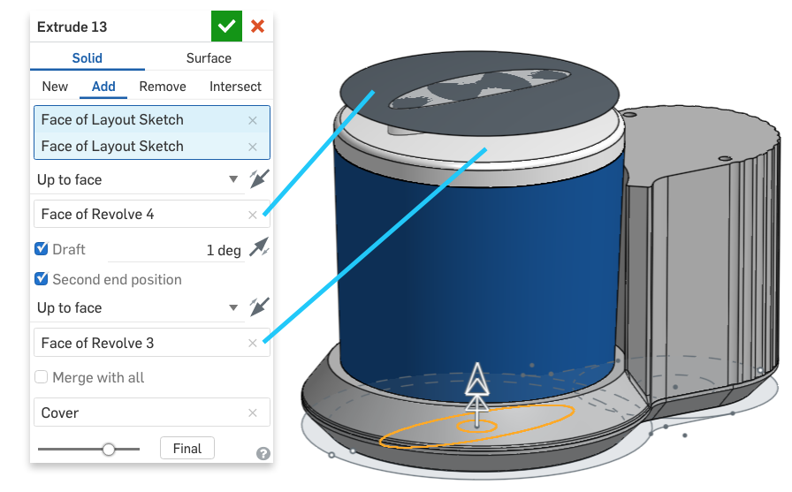

1. Next delete the two surface parts and rename the new part “Cover”:

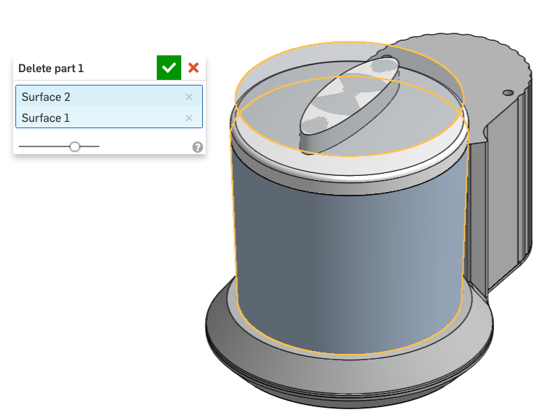

*Pro Tip: This may seem a bit counterintuitive, but we have just created a feature called “Delete Part”. This isn’t the same as deleting a feature in the feature list or just hitting the delete key, and that is because just like any other feature, “Delete Part” feature can be suppressed, reordered, and edited. In this case, we created surfaces temporarily - as tools - to operate on our solid geometry. Above, we used the top rounded surface to create a nice rounded handle for the cover of our Bowl. There are many other applications for this technique and there are other ways to create this geometry, however it is presented here as yet another way to design. Hopefully it causes other ideas to pop up in your head!*

1. Next, add two fillets to the cover:

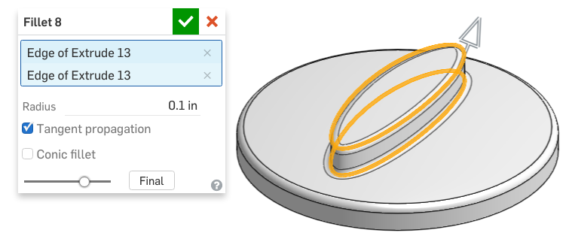

1. Next, let’s shell the Cover:

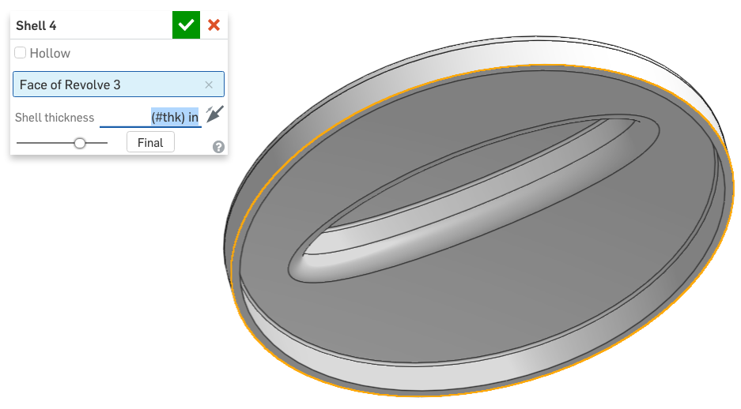

1. Finally, let’s change the appearance of our Chopper Bowl and Cover by altering the opacity, to show that it is transparent. Select the two parts in the Parts sidebar and right-click. Choose “Edit appearance...”:

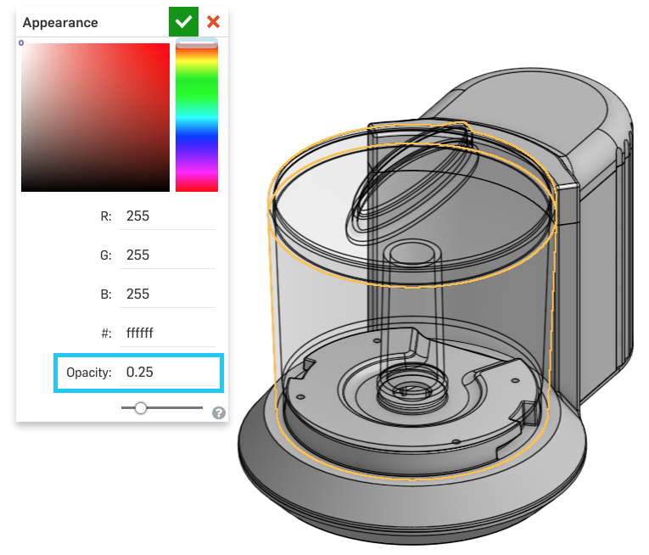

Congratulations on finishing the first part of the Chopper project! We’ve learned how to apply Top-Down design techniques to create an impactful consumer product which can be easily manufactured. In doing so, we have created a smart, robust CAD model with plenty of documented design intent. Now that we have completed the lesson, let’s create a Version called “V1”. Your design should now look like this:



# 

# Summary

Let’s take a second to reflect what we learned in this lesson.

1. We learned about using drafts and why they’re important in some manufacturing processes, such as plastic injection molding.
2. We learned about extruding a one-dimensional curve to create a two-dimensional surface.
3. We learned how to split parts using a surface and plane.
4. We learned that variables and mathematical expressions can be very helpful in documenting design intent.

Next week, we’ll be focusing on the internal components of the Chopper, like the gears and shafts that drive its rotating function. Stay tuned!